Lecture # 7:

Objective:

- Combo-box
- Picture Box
- Dialog Result
- Color Dialog
- Open File Dialog

COMBOBOX:
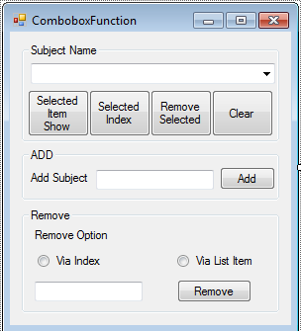

using System;
using System.Collections.Generic; using System.ComponentModel; using System.Data;
using System.Drawing; using System.Linq; using System.Text;
using System.Windows.Forms;

namespace COMBOBOX
{
public partial class Form1 : Form
{
public Form1()
{

InitializeComponent();
}

private void groupBox1_Enter(object sender, EventArgs e)
{

}

private void btnRemove_Click(object sender, EventArgs e)
{
if (txtRemove.Text != string.Empty)
{
if (rdobtnIndex.Checked)
{

try
{

}

int ehIndex = int.Parse(txtRemove.Text); cmbxSubject.Items.RemoveAt(ehIndex);

catch (Exception)
{

MessageBox.Show("Index should be numeric"); return;
}
}
else
{
cmbxSubject.Items.Remove(txtRemove.Text);
}
}
}

private void txtExit_Click(object sender, EventArgs e)
{
Application.Exit();
}

private void btnShowSelected_Click(object sender, EventArgs e)
{
if (cmbxSubject.SelectedIndex == -1)
{
MessageBox.Show("No Element is selected"); cmbxSubject.Focus();
}
else
{
MessageBox.Show(cmbxSubject.SelectedItem.ToString());
}
}

private void btnShowIndex_Click(object sender, EventArgs e)
{
if (cmbxSubject.SelectedIndex == -1)
{
MessageBox.Show("No Element is selected"); cmbxSubject.Focus();

}
else
{
MessageBox.Show(cmbxSubject.SelectedIndex.ToString());
}
}

private void btnRemoveItem_Click(object sender, EventArgs e)
{
if (cmbxSubject.SelectedIndex == -1)
{
MessageBox.Show("No Element is selected"); cmbxSubject.Focus();
}
else
{

cmbxSubject.Items.Remove(cmbxSubject.SelectedItem.ToString());
}
}

private void btnClear_Click(object sender, EventArgs e)
{
cmbxSubject.Items.Clear();
}

private void btnAdd_Click(object sender, EventArgs e)
{
if (txtAdd.Text == string.Empty)
{
MessageBox.Show("No element to be added"); txtAdd.Focus();
}
else
{
cmbxSubject.Items.Add(txtAdd.Text);
}
}
}
}

PICTURE BOX:
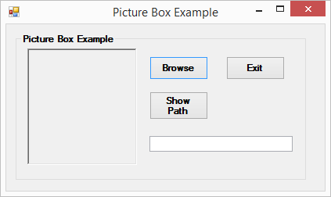

using System;
using System.Collections.Generic; using System.ComponentModel; using System.Data;
using System.Drawing; using System.Linq; using System.Text;
using System.Windows.Forms;

namespace COMBOBOX
{
public partial class pICTUREBOX : Form
{
public pICTUREBOX()
{
InitializeComponent();
}

private void button1_Click(object sender, EventArgs e)
{
DialogResult dr = openFileDialog1.ShowDialog(); if (dr == DialogResult.OK)
{
pbx.Image = Image.FromFile(openFileDialog1.FileName);
}

}

private void btnExit_Click(object sender, EventArgs e)
{
Application.Exit();
}

private void btnPath_Click(object sender, EventArgs e)
{
if (pbx.Image != null)
{
txtPath.Text = openFileDialog1.FileName;
}
}
}
}

COLOR DIALOG BOX:
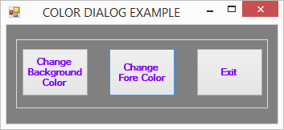

using System;
using System.Collections.Generic; using System.ComponentModel; using System.Data;
using System.Drawing; using System.Linq; using System.Text;
using System.Windows.Forms;

namespace COMBOBOX
{
public partial class COLORDIALOG : Form
{
public COLORDIALOG()
{
InitializeComponent();
}

private void button1_Click(object sender, EventArgs e)
{
DialogResult dr = colorDialog1.ShowDialog(); if (dr == DialogResult.OK)
{
this.BackColor = colorDialog1.Color;
}
}

private void button2_Click(object sender, EventArgs e)
{
DialogResult dr = colorDialog1.ShowDialog(); if (dr == DialogResult.OK)
{
this.ForeColor = colorDialog1.Color;
}
}

private void button3_Click(object sender, EventArgs e)
{
Application.Exit();
}
}
}

